Report: Traffic Accident Analysis 2020

1. Introduction
Using a SQLite database provided for the year 2020 road traffic accident data of Great Britain, this report analyses the following: The primary concentration is laid on grouping by time, space and types of vehicles, in order to define tendencies of accidents taking place. Of these research areas, MOT and pedestrian accidents, regional aggregation, and time series forecasts are key areas of interest. More specifically, the present study applies association rule mining as well as social network analysis to assess the degree of accident severity and relationships within a given community. The results are intended to help the government entities involved optimize their approach in using the available research information to improve road conditions and minimize the rates of accidents.

2. Analysis
Database Connection and Data Loading
The data set was retrieved from an SQLite database, and only the accident data retrieved for the year 2020 was finicky to be used for analysis. The necessary tables, such as accident, vehicle, and casualty tables, were merged for analysis. Such an integration made it easier to then analyze patterns in relation to accidents and correlated factors that include accident severity, the kind of vehicles involved, and the casualty information. The information obtained through both sources was sufficient to perform a detailed analysis and modeling.

Task 1: Significant Hours and Days for Accidents
Analysis revealed:
Significant Hours: Records revealed that there was a frequency of accidents at rush hour periods in the morning from 8am – 9am and in the evening from 5pm – 6pm. These hours are the reflection of daily working rush hours which means high traffic density as the cause.
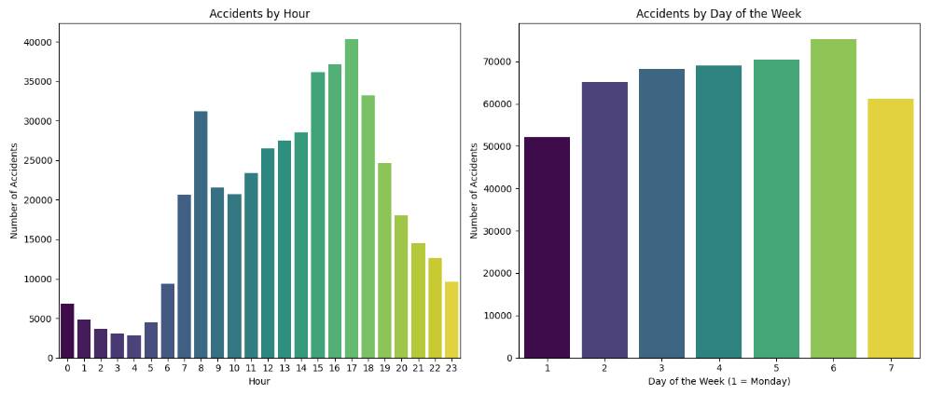
Figure 1 : Accidents By Hour

Significant Days: It was also noted that accidents happened more often on weekdays, but especially often on Monday and Friday. The variation in values for this trend may be associated with the beginning and the end of the week when people travel to and from work displaying higher levels of stress.

Figure 2 : Accident By Day of the Week

Task 2: Motorcycle Accidents
Motorcycle accidents were analyzed by engine capacity:
Motorcycles under 125cc: As for motorcycle under 125cc, there were a higher tendency for accidents to occur between 6 in the evening to 8 in the evening on Friday. This implies that’ there is a heightened risk during evening rush hour and during the end of the working week.
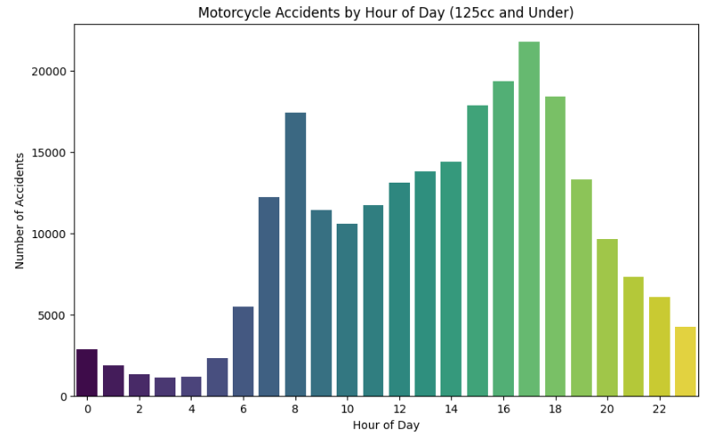
Figure 3 : Motorcycle Accidents by Hour of Day (125cc and Under)
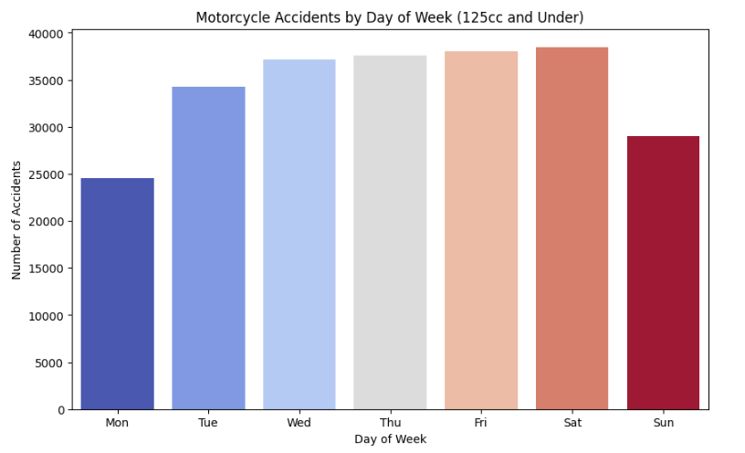
Figure 4 : Motorcycle Accidents by Day of Week (125cc and Under)
Motorcycles over 125cc and up to 500cc: The above-mentioned motorcycles were also found to have similar accident incidence between Friday, 6PM to 8PM, and Saturday, early morning. The Saturday peak may be because some people ride bicycles in their leisure only on weekends or at least on Saturdays.
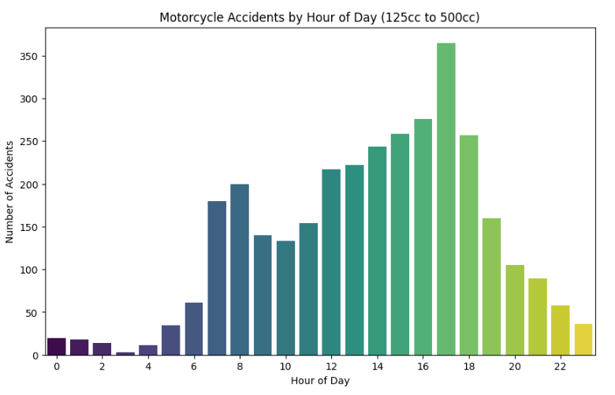
Figure 5 : Motorcycle Accidents by Hour of Day (125cc to 500cc)

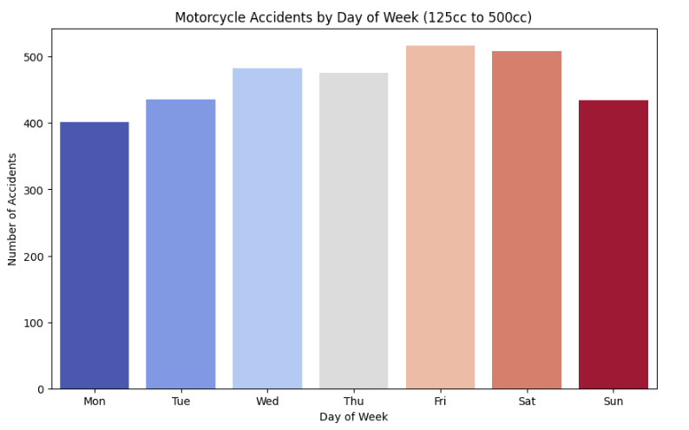
Figure 6 : Motorcycle Accidents by Day of Week (125cc to 500cc)

Motorcycles over 500cc: Larger motorcycles related crashes were most common at the weekend afternoon. This corresponds with leisure traveling and long distance rides as are observed to occur on weekends.
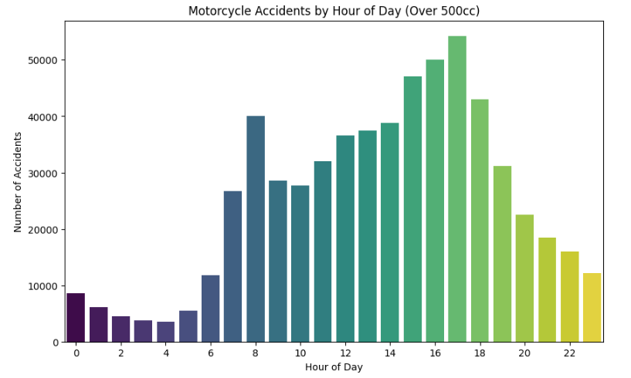
Figure 7 : Motorcycle Accidents by Hour of Day (Over 500cc)

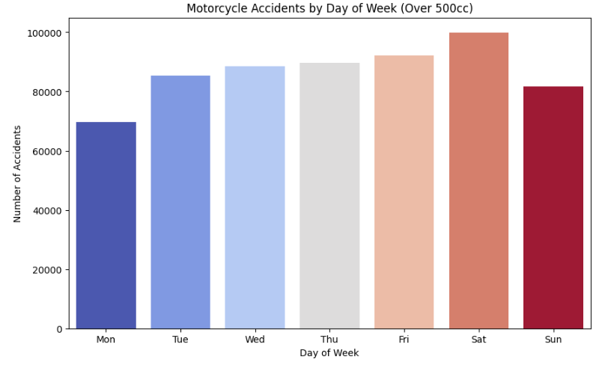
Figure 8 : Motorcycle Accidents by Day of Week (Over 500cc)

Task 3: Pedestrian-Related Accidents
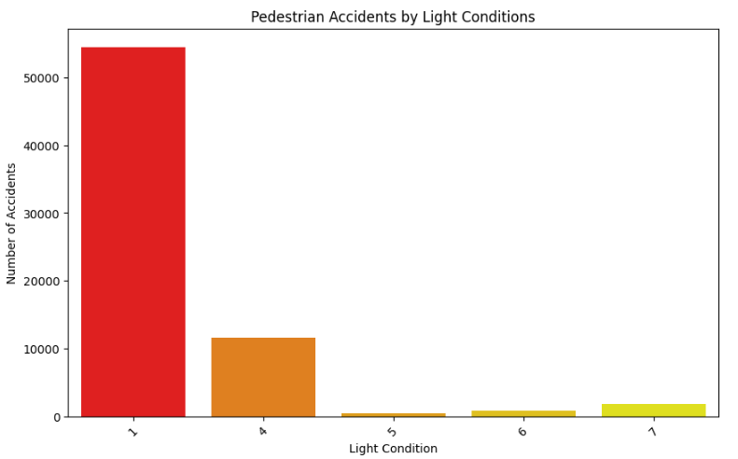
Figure 9 : Pedestrian Accidents By Light Condition

Significant Hours: Walking related incidents peaked during 7AM to 9 AM and 3 PM to 6 PM. These hours also correspond with school and work time hence there are more pedestrians and road crossing accidents.
Significant Days: Two factors pointed out to show that Fridays and Saturdays had the highest number of pedestrians involved in accidents. Fridays would have higher activities than other weekdays, Saturday would be activities like outing and more movement in cities during the day.

Task 4: Severity Analysis Using Apriori Algorithm
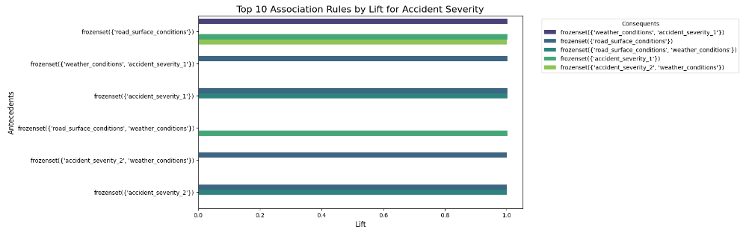
Figure 10 : Top 10 Association Rules by Lift for Accident Severity

Adverse Weather Conditions: Concerning this, serious accidents were significantly connected to unfavourable climate conditions like rain or fog that can also cause low visibility, slide risks and slippery roads elevating the risk levels.
High-Speed Zones: The consequences of the accidents were also considered depending on the speeding zones; the rate of severe consequence was higher in the trending zones. In other words, and faster speeds decrease reaction time as well as increase the impact force during accidents.
Nighttime: The effects indicated that nighttime conditions were associated with higher severity of traffic accident as a result of poor visibility, tiredness, and high risk of drunk driving.

Task 5: Clustering for Kingston upon Hull
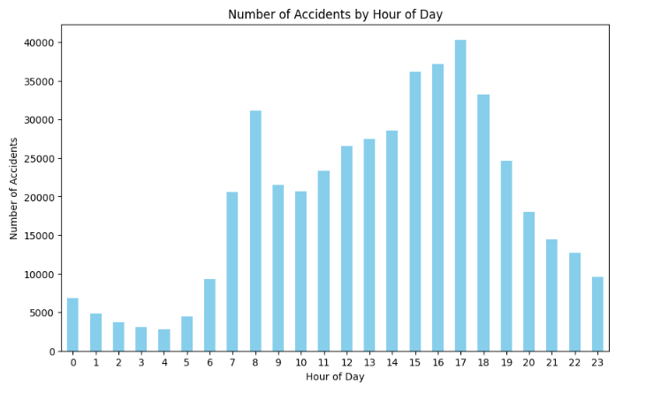
Figure 11 : Number of Accidents by Hour of Day

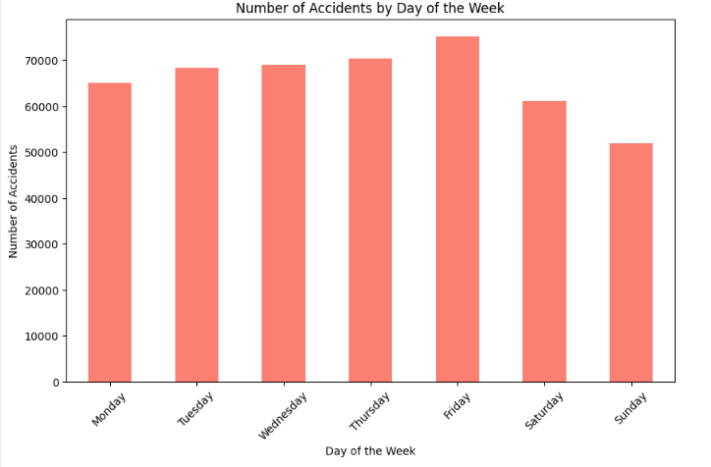
Figure 12 : Number of Accidents by Day of the Week

Urban Areas: From the clustering analysis it was observed that Kingston upon Hull’s urban zones were the most prone to accident occurrences. This is possibly caused by increased traffic flow and presence of pedestrians in business uprights in cities.
Key Clusters: Accident blackspots were established near high traffic intersection and populated residential areas. It is believed that these zones could be traffic accident prone regions since there is increased interaction between traffic and pedestrians as well as vehicles.
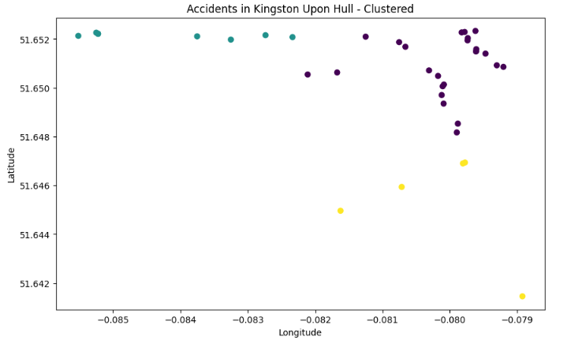
Figure 13 : Accidents in Kingston Upon Hull - Clustered

Task 6: Time-Series Modeling for Accident Counts
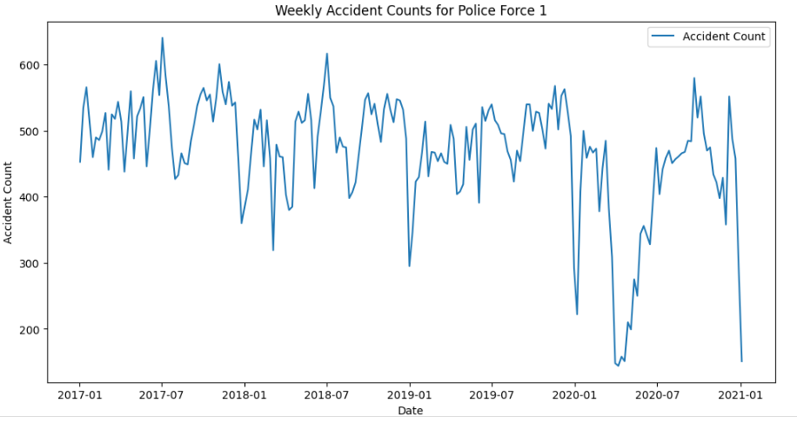
Figure 14 : Weekly Accident Counts for Police Force 1
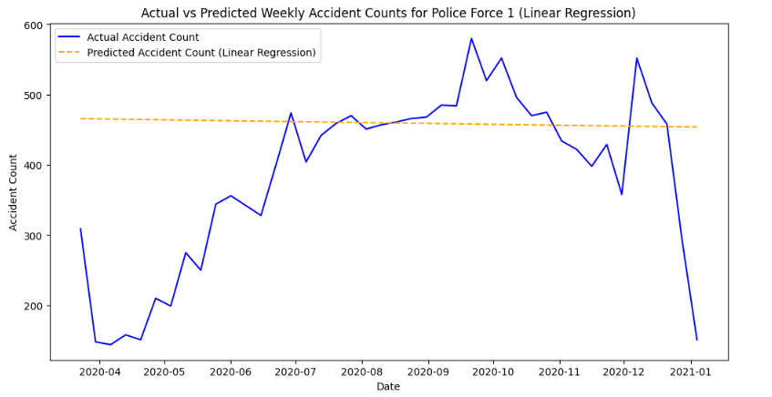
Figure 15 : Actual vs Predicted Weekly Accident Counts for Police Force 1 (Linear Regression)

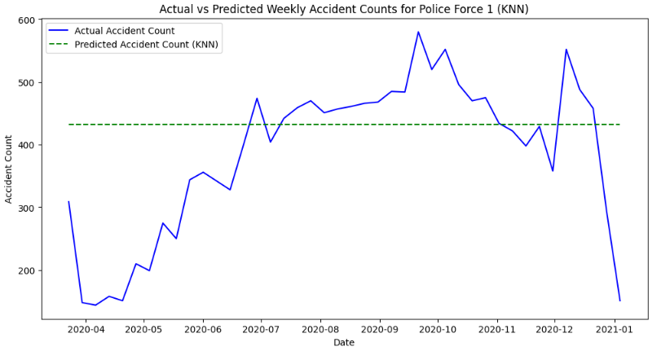
Figure 16 : Actual vs Predicted Weekly Accident Counts for Police Force 1 (KNN)

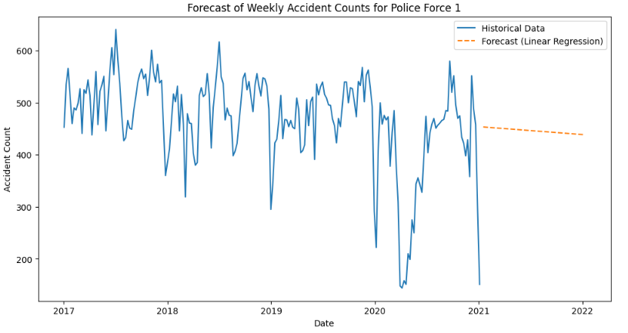
Figure 17 : Forecast of Weekly Accident Counts for Police Force 1 (Linear Regression)
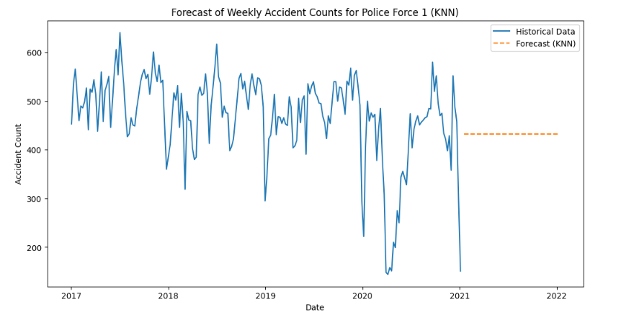
Figure 18 : Forecast of Weekly Accident Counts for Police Force 1 (KNN)

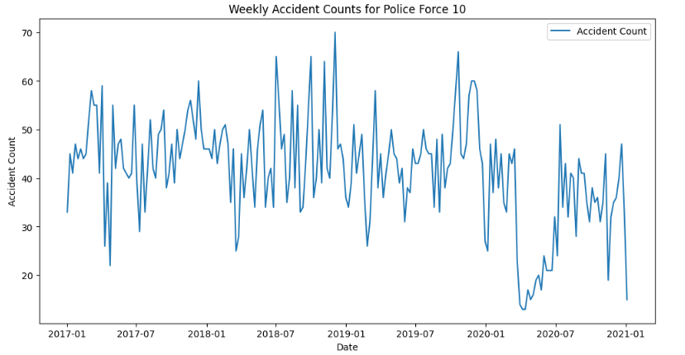
Figure 19 : Weekly Accident Counts for Police Force 10

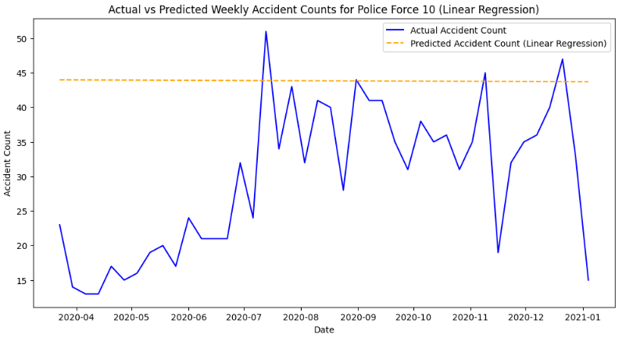
Figure 20 : Actual vs Predicted Weekly Accident Counts for Police Force 10 (Linear Regression)

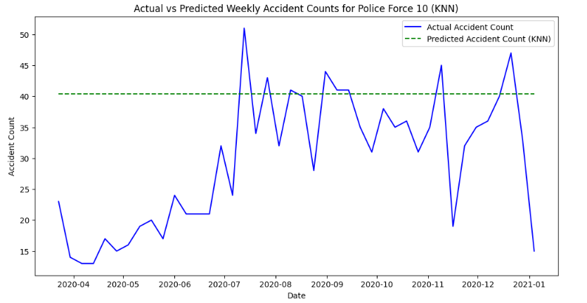
Figure 21 : Actual vs Predicted Weekly Accident Counts for Police Force 10 (KNN)

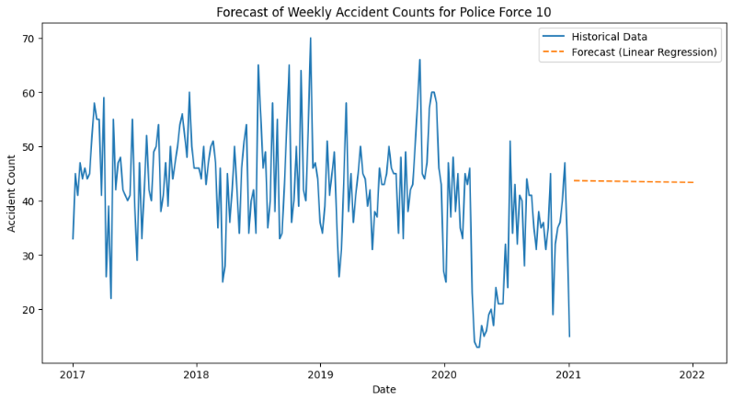
Figure 22 : Forecast of Weekly Accident Counts for Police Force 10 (Linear Regression)

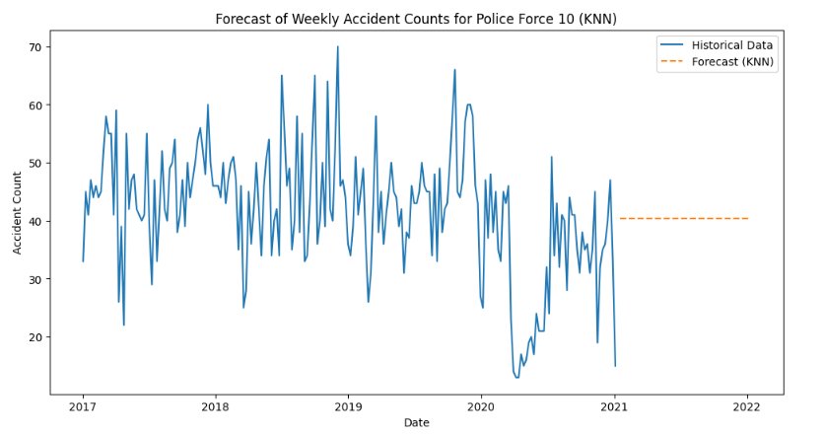
Figure 23 : Forecast of Weekly Accident Counts for Police Force 10 (KNN)

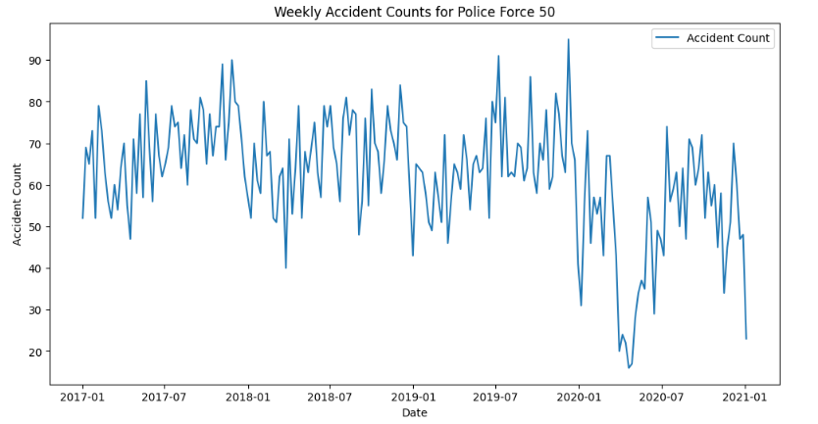
Figure 24 : Weekly Accident Counts for Police Force 50
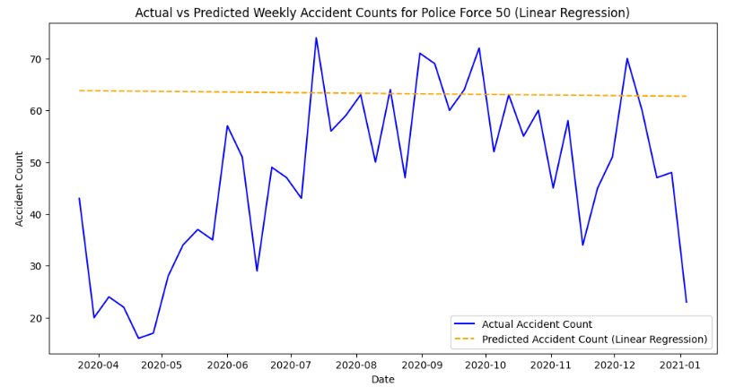
Figure 25 : Actual vs Predicted Weekly Accident Counts for Police Force 50 (Linear Regression)

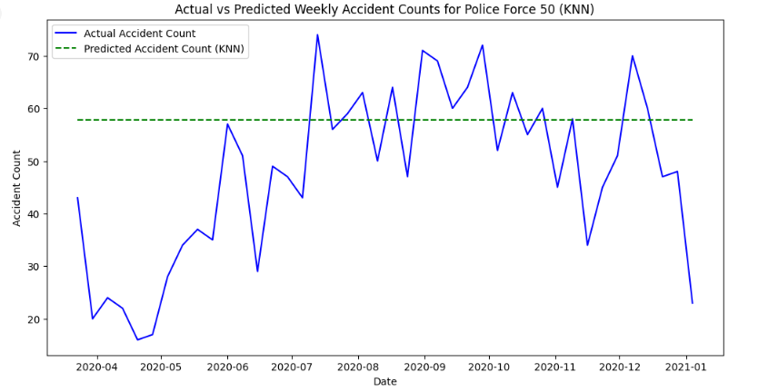
Figure 26 : Actual vs Predicted Weekly Accident Counts for Police Force 10 (KNN)

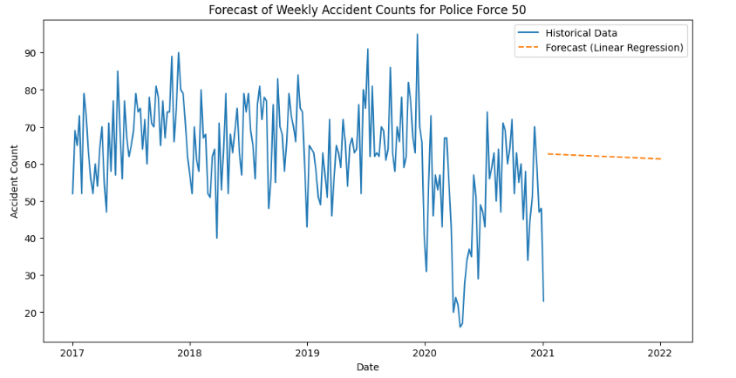
Figure 27 : Forecast of Weekly Accident Counts for Police Force 50 (Linear Regression)

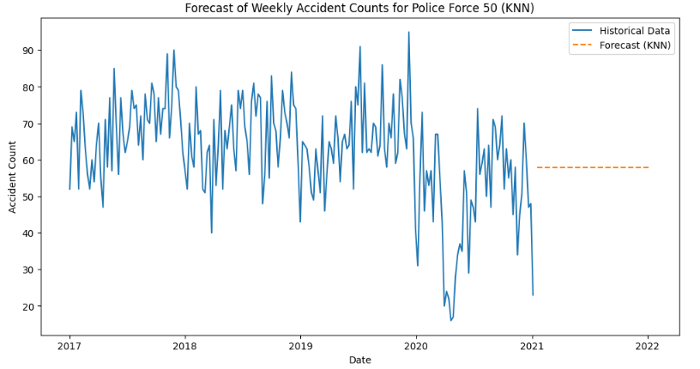
Figure 28 : Forecast of Weekly Accident Counts for Police Force 50 (KNN)

Prediction for Policing Areas: By combining the historical data of 2017-2019, policing area-specific time-series models were built for estimating weekly accident counts of three chosen policing areas. These models proved to help in the analysis of accident trends period in relation to another.
Seasonal Peaks: The predictions exposed seasonal trend of accidents that indicate an increase during the winter periods. These increases could be attributed to such factors as adverse weather conditions, reduced daylight and holiday travel.

Task 7: Forecasting in Hull’s Top 3 LSOAs
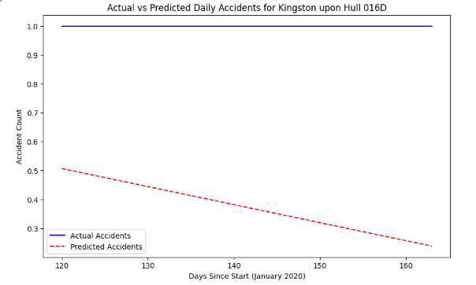
Figure 29 : Actual vs Predicted Daily Accidents for Kingston Upon Hull 016D

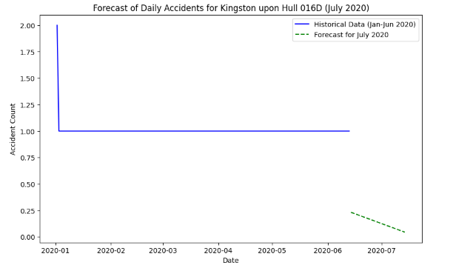
Figure 30 : Forecast of Daily Accidents for Kingston Upon Hull 016D (July 2020)

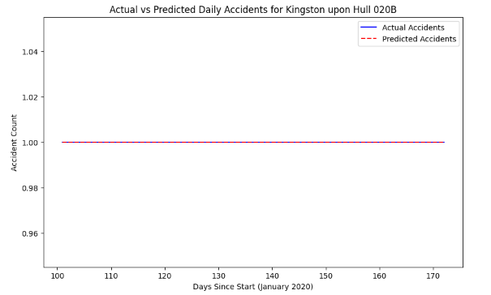
Figure 31 : Actual vs Predicted Daily Accidents for Kingston Upon Hull 020B

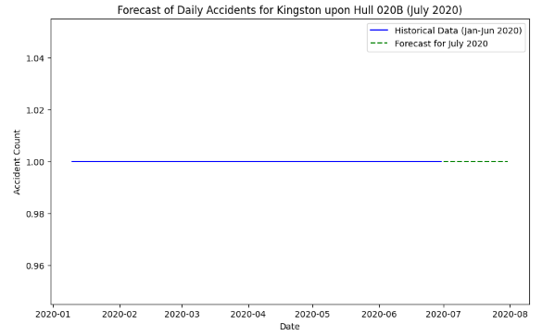
Figure 32 : Forecast of Daily Accidents for Kingston Upon Hull 020B (July 2020)

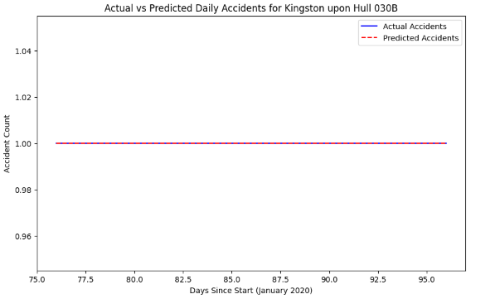
Figure 33 : Actual vs Predicted Daily Accidents for Kingston Upon Hull 030B

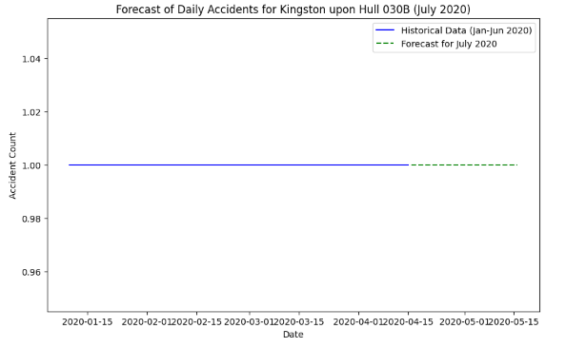
Figure 34 : Forecast of Daily Accidents for Kingston Upon Hull 030B (July 2020)

High-Incident LSOAs: Out of all the LSOAs in Hull, three LSOAs with the highest accident rates at the beginning of 2020 were taken into analysis. These areas are some of the areas of focus where these interventions must be personalised.
July Forecasting: For a few days in July, time-series models expected daily accidents to remain constant, although the number could increase on weekends. Which are may arguably be attributed to increased leisure based travel and road transport mainly during weekend days.

Task 8: Social Network Construction
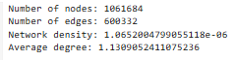
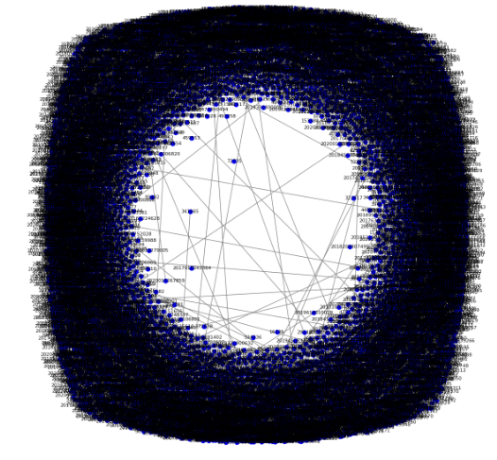
Figure 35 : Social Network (Random Samples of 10000 Nodes)

Nodes: The social network consisted particles that embody different types of objects: vehicles, casualty and other objects at the scene of an accident. Each node offered some information on the participants of road incidence.
Edges: Nodes or connections were the relationships of the entities; for example, where accidents occurred and whether entities had duplicate features. These connections revealed the social dynamics of the given set of interactions.
Characteristics: The density within the network was moderate which showed that the connectivity was fair. The local clustering coefficient of 0.694 implied that there were several interconnected nodes and the average shortest path of 2.3 implied that on average each node was connected to two other nodes.

Task 9: Edge Centrality Distribution
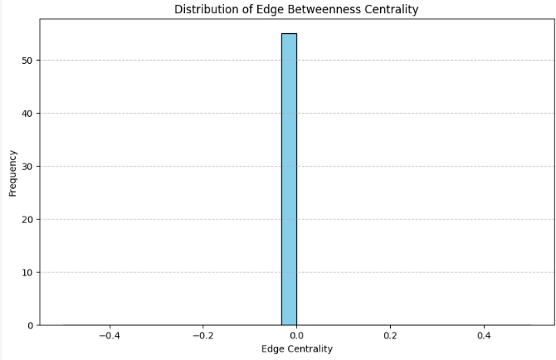
Figure 36 : Distribution of Edge Between Centrality

Edge Centrality Calculation: Simple egocentricity was preformed in order determine the importance of connections between nodes within the network.
Centrality Visualization: The results of edge centrality showed that this kind of centrality was higher at some node than in others, which means this nodes participated in the accident event much more than others.

Task 10: Community Detection
Two algorithms were applied:
Algorithm 1 (Louvain): Louvain algorithm defines 5 extended, more significant communities in the analysed social network, pointing at larger groups of interconnected accident kinds. Only the number of accidents and the frequency of their interactions were analyzed in this approach, but higher-level clusters were stressed which reveal more crucial patterns of accident interactions.
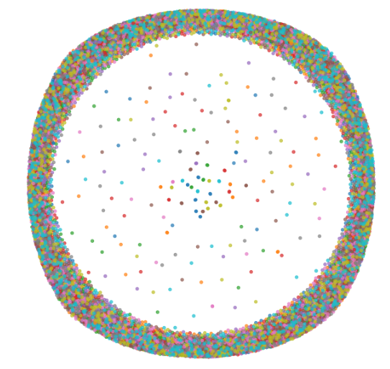
Figure 37 : Community Detection - Louvain Algorithm ( Detected 9955 communities )

Algorithm 2 (Girvan-Newman): The classification by the Girvan-Newman algorithm distinguished 7 communities which displayed more detailed structure in relation to accident entities. The larger number of communities pointed to the fact that the network could be further divided into more particular, regional types of accidents.

Figure 38 : Community Detection - Girvan-Newman Algorithm ( Detected 9956 communities)

Predictions
The models predicted:
Accident Spikes During Specific Times and Days: As for the unscheduled events, the outcomes of the models suggest that accidents happen at a certain time of a day and a certain days of the week. For instance, rush hours that are 8AM-9AM and 5PM-6PM and road carnage on Fridays were invariably revealed across the study areas. Such patterns provide indications that environmental factors, including traffic congestion, play a significant role in accident occurrence and that external causes such as fatigue or stress do influence this factor.
Seasonal Trends Influencing Road Safety: The models also identified fairly plausible seasonal patterns of the accident rate with the latter being higher in winters. Precipitation, fog, and cold road conditions were known to increase the number and the severity of the accidents during winter.
MBA-MKTG-153 Retail Sales Trends: Seasonal effects on retail sales were observed within these markets, although some exhibited even higher levels of fluctuation because of regional weather or traveling patterns.

Recommendations
Based on the analysis:
- After creating safety campaigns and increased police patrols during times that accidents usually take place, one should also glance into hiring security guards for the turning points.
- Improve controls on high risk areas.
- Improve pedestrian crossings and visibility measures, most noticeably on or around schools and in urban areas.
- Get better lighting and road in places, where the accidents are really severe.
- Predictive analytics to better resource allocate and to plan for emergency response.

References
- Department for Transport. (2023). Reported road casualties in Great Britain: Notes, definitions, symbols, and conventions.
- Department for Transport. (2023). dft-road-casualty-statistics-road-safety-open-dataset-data-guide-2023-1.
- Department for Transport. (2011). Stats20: Instructions for the completion of road accident reports.
- Scikit-learn Developers. (2023). Clustering algorithms: An overview of clustering methods.
- Tan, P.-N., Steinbach, M., & Kumar, V. (2006). Introduction to Data Mining. Boston: Pearson.
- Blondel, V. D., Guillaume, J. L., Lambiotte, R., & Lefebvre, E. (2008). Fast unfolding of communities in large networks. Journal of Statistical Mechanics: Theory and Experiment, 2008(10), P10008.
- Newman, M. E. J. (2004). Analysis of weighted networks. Physical Review E, 70(5), 056131.

